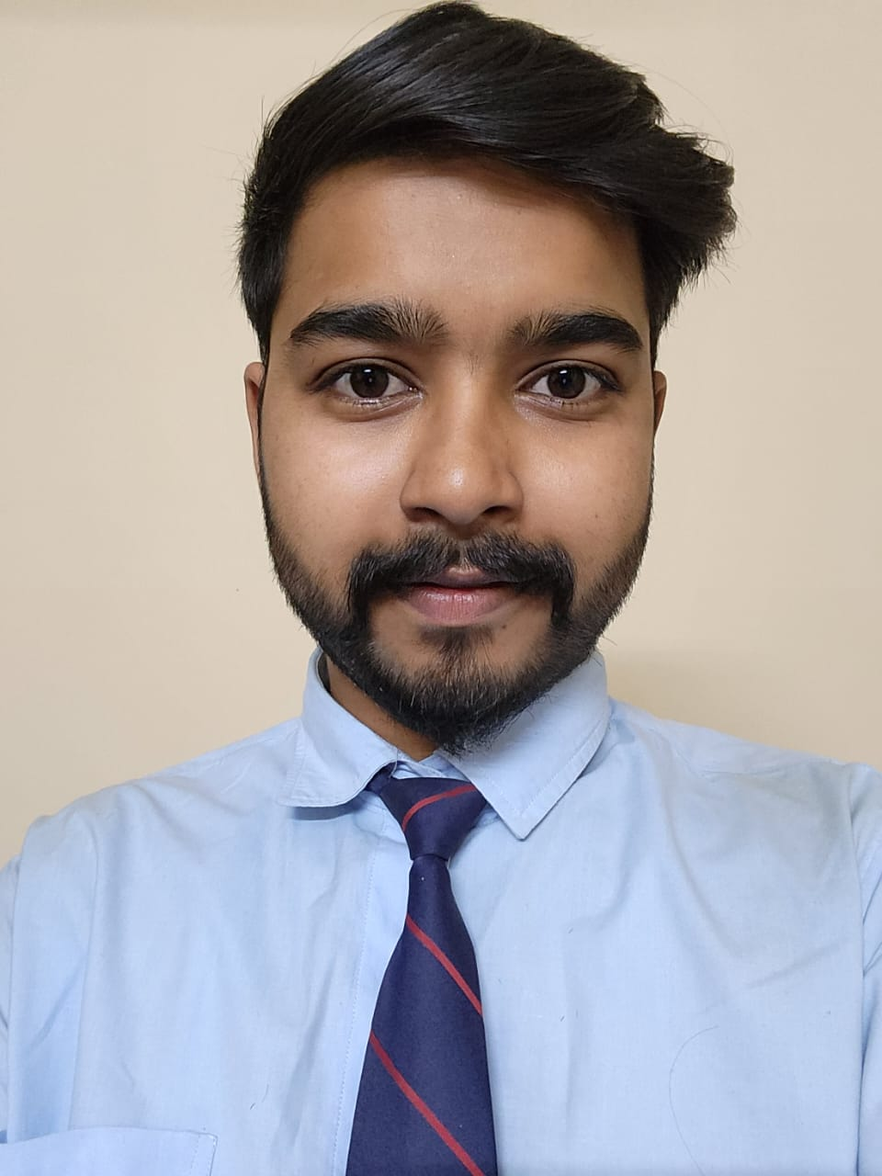
SAKSHAM SHARAN SHRIVASTAVA
Address : Flat-301, Trishla Apartment, Bhawarkuwa, Indore (M.P)

+91–7999713528 Gmail : sakshamshrivastav20256@acropolis.in
saksham-sharan-shrivastava-046328249
CAREER OBJECTIVE:
Seeking to obtain a creative and challenging position in an leadership, while contributing to the symbolic growth of the organization with my technical, innovative and logical skills.
SKILLS:
- C Language
- Java
- C++ Language
- OOPM

ACHEIVEMENTS:
- Lead School Parade as Head Boy.
- Gold Medalist in School for Highest Marks in 10th and 12th.
STRENGTHS:
- Team Work
- Quick Learner
- Leadership
AREA OF IMPROVEMENT:
- Issues with delegating Tasks
- Confidence
HOBBIES:
- Cooking (North Indian Food)
- Listening Music
PERSONAL DETAILS
Date of Birth : 21/09/2001
Gender : MALE
Marital Status : Unmarried
Nationality : INDIAN
Mother Tongue : Hindi
Languages Known: English & Hindi
Passport details : Applied
Father’s Name: Shailendra Shrivastava
Permanent Add. : NEW Bus Stand,
Shahdol (M.P.)

ACADEMIC RECORD:
- Bachelors of Technology in Computer 8.1 CGPA
Science & Information Technology
Acropolis Institute of Technology and Research, Indore (M.P)
- Higher Secondary (12th MP Board ) 88.8%
St. Aloysius Sr. Sec. School , Shahdol (M.P)
- Senior Secondary (10th MP Board ) 91.3%
St. Aloysius Sr. Sec. School , Shahdol (M.P)
PROJECTS:
- College Bus Tracker App :
It’s an android application which was able to track college buses, and provides information about the routes of the buses and their arrival timings.
Role Frontend Developer Duration 60-70 days
- Restaurant Kiosk App:
Android Application for ordering food with online with the help of QR Menu and lot of ease because of its User Interface.
Role Frontend Developer Duration (Currently working)

TRAINING/INTERNSHIP:

- Drone Technology and Sensization Training Programme :
Bootcamp organized by AICTE
[Sep 2022 – Oct 2022]
- Cyber Security Training Programme :
Training accomplished with Fortinet
[March 2022 – April 2022]
- Web Development & Designing Internship :
Company – OASIS Infobyte
[March 2023 – present]

CERTIFICATES :
- AWS CLOUD PRACTITIONER (2023-2026)
(Certified By Amazon Web Services)
- NSE – 1 (Network Security Expert)
(Certified By Fortinet)
- DIGITAL MARKETING
(Certified By Great Learning)
- AWS Academy Graduate Cloud Foundations
(Certified By Amazon Web Services)

Declaration: I hereby declare that the information above is true to best of my knowledge.

Date: 23/03/2023
Place: Indore Saksham Sharan Shrivastava


